**Supporting information for: Using plant invasions to compare occurrence- and abundance-based calculations of biotic homogenization: are results complementary or contradictory?**

TABLES:

|  |  |  |
| --- | --- | --- |
|  | Environmental matching | Spatial matching |
| Occ H | Abn H | 42.3% | 39.7% |
| Occ D | Abn H | 14.3% | 15.8% |
| Occ D | Abn D | 34.8% | 36.6% |
| Occ H | Abn D | 9.6% | 7.9% |
| Pearson correlation coefficient | .71 | .75 |

**Table S1: The likelihood of agreement and disagreement between occurrence- and abundance-based metrics of biotic homogenization/differentiation was comparable when invaded and uninvaded plots were matched based on environmental similarity and minimum spatial distances.**

FIGURES:

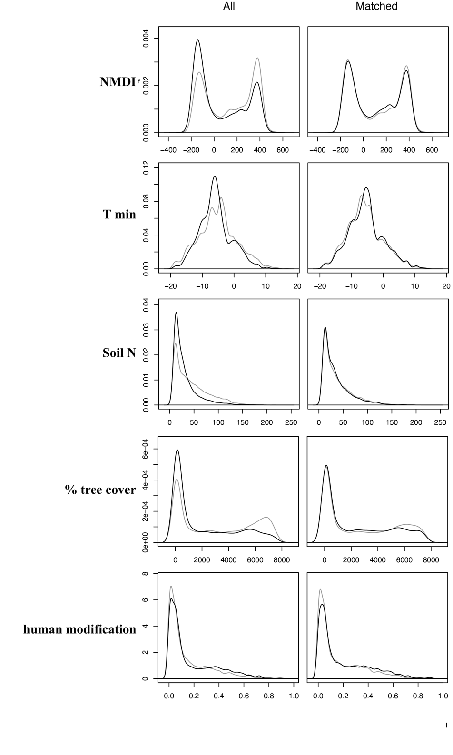

**Figure S1: Results of propensity score matching to match environmentally similar uninvanded and invaded plots.** The left column shows the distribution of environmental variables in uninvaded (gray) and invaded plots (black) for the whole dataset and the right column shows the distributions after matching.

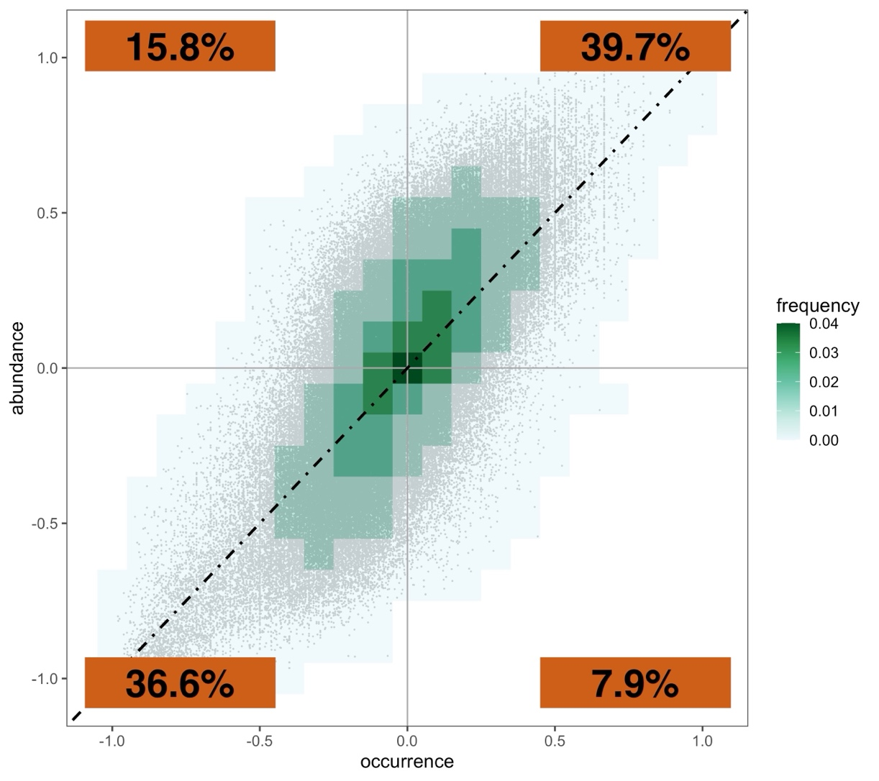

**Figure S2: Frequency of pairwise relationships between occurrence- and abundance-based calculations of change in beta diversity among spatially corresponding invaded and uninvaded plots of the SPCIS database.** Percentages on the heatmaps describe the number of plot comparisons that fall into each bin. The percentages in the orange boxes on the plots represent the percentage of points that fall into each graphical quadrant.